WSJT-X User’s Guide

Version 1.2

Joe Taylor, K1JT

Copyright © 2014
January 15, 2013

Contents
Introduction 3
System Requirements 3
Installation and Setup 4
Basic Operating Tutorial 6
Making QSOs 12
On-Screen Controls 14
Status Bar 18
Menus 18
Keyboard Shortcuts 20
Special Mouse Commands 21
Font Sizes 21
Differences Between JT65 and JT9 21
Appendix A: The JT9 Protocol and its Implementation 22
Appendix B: Installed and Generated Files 24
Appendix C: Linux, OS X, and Compiling from Source Code 26
Source Code 26
Acknowledgments 26

Introduction
WSJT-X is a computer program designed to facilitate basic amateur radio communication using very weak signals. The first four letters in the program name stand for “Weak Signal communication by K1JT”, and the “-X” suffix indicates that WSJT-X started as an extended (and experimental) branch of program WSJT.
Version 1.2 of WSJT-X offers two protocols or “modes,” JT9 and JT65. Both are designed for making reliable, confirmed QSOs under extreme weak-signal conditions. They use nearly identical message structure and source encoding. JT65 was designed for EME (“moonbounce”) on the VHF/UHF bands and has also proved very effective for worldwide QRP communication at HF. JT9 is optimized for the LF, MF, and HF bands. It is about 2 dB more sensitive than JT65 while using less than 10% of the bandwidth. Both modes use one-minute timed sequences of alternating transmission and reception, so a minimal QSO takes 4 to 6 minutes — two or three transmissions by each station, one sending in odd minutes and the other even. World-wide QSOs are possible with power levels of a few watts and compromise antennas.
Starting with version 1.1, WSJT-X provides dual-mode reception of both JT65 and JT9 signals and can display bandwidths as large as 5 kHz. If your receiver can provide at least 4 kHz bandwidth in USB mode, you can set your dial frequency to one of the standard JT65 frequencies — for example, 14.076 MHz for 20 meters — and have the full JT65 and JT9 sub-bands displayed simultaneously on the waterfall. You can make QSOs in both modes using nothing more than mouse clicks.
Plans for future program development call for WSJT-X and WSJT to merge together: WSJT-X will gradually acquire the additional modes JT4, FSK441, JTMS, and ISCAT that are now supported in WSJT. The entire WSJT-related effort is an open-source project. If you have programming skills or would like to contribute to the project in other ways, please make your interests known to K1JT and the rest of the development team. The project’s source-code repository can be found at http://developer.berlios.de/projects/wsjt/, and communication among the developers takes place on the email reflector wsjt-devel@lists.berlios.de. You can subscribe to this list at https://lists.berlios.de/mailman/listinfo/wsjt-devel.

System Requirements
- SSB transceiver and antenna
- Computer running Windows XP or later, or Linux, OS X or other unix-like operating systems. (See Appendix C for instructions concerning non-Windows systems.)
- 1.5 GHz or faster CPU and 100 MB of available memory
- Monitor with at least 1024 x 780 resolution (more is better)
- Audio input and output devices supported by your operating system
- Computer-to-radio interface using a serial port for T/R switching, or CAT control, or VOX.
- Audio or equivalent USB connections between transceiver and computer
- A means for synchronizing your computer clock to UTC to within ±1 s. The built-in Windows facility is usually not adequate. I recommend Meinberg NTP: see http://www.satsignal.eu/ntp/setup.html for installation instructions.

Installation and Setup
- WSJT-X can be downloaded from the WSJT Home Page, http://www.physics.princeton.edu/pulsar/K1JT/. Click on the WSJT-X link at the left margin and then on the appropriate download link.
- Under Windows, execute the downloaded file and follow its installation instructions. Install WSJT-X into its own directory (the suggested default is C:\WSJTX) rather than the conventional C:\Program Files\WSJTX. By default all files relating to WSJT-X will be stored in your chosen installation directory and its subdirectories. You can uninstall WSJT-X simply by removing the installation directory and its contents. See Appendix C for other operating systems.
- Start WSJT-X and Select Configuration from its Setup menu. Enter your callsign and Maidenhead grid locator as shown in the screen shot on the next page, and set the remaining parameters as required for your station. A very simple setup might use PTT method = VOX and PTT Port = None. Stations already configured for other digital modes will typically use PTT method = DTR or RTS, and a serial communication port such as COM1 for PTT Port.
- Many users have other software controlling their radios. WSJT-X does not implement full transceiver control, but it does provide a way to ensure that WSJT-X can read and set the radio’s dial frequency. If you want this capability check the box Enable CAT, select your radio type from a drop-down list, and select a port (not the same port selected for PTT control) and whatever serial communication parameters may be required for your radio. For now you should leave Split Tx unchecked. If using CAT control, most radios will allow you to set PTT method = CAT. Some radios support two types of PTT assertion via CAT control: one takes audio input from the Mic connector, the other from a rear-panel Data connector. The simplest CAT configuration sets Polling interval to 0 (no polling the radio for dial frequency). WSJT-X will then be able to set the radio’s frequency, but the program will be unaware of subsequent changes made using the radio’s panel controls. With most radios you can set Polling interval to a reasonable small number (say 1 – 3 s) and the program will follow any frequency changes made at the radio. Note that you may not be able to simultaneously control your radio from WSJT-X and from another software program. Some experimentation may be required, and you may need to refer to the documentation for your CAT software and radio. It is best to have the radio and any interface equipment turned on and connected before starting WSJT-X, and to exit the program before turning your equipment off.
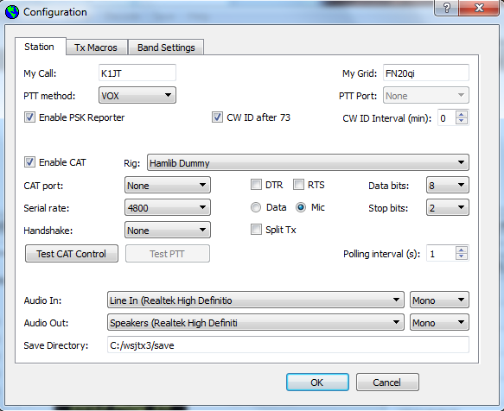
- If you use Commander or Ham Radio Deluxe to control your transceiver, you can configure WSJT-X to communicate with the radio through that program. Entries for these programs appear at the end of the drop-down list of supported rigs.
- Try clicking the Test CAT Control and Test PTT buttons to see that you have established the desired control of station functions. Select the devices you will use for Audio input and output, then click OK to dismiss the Configuration window.
- WSJT-X expects your sound card to do its raw sampling at 48000 Hz. To ensure that this will be so when running under Windows, open the Sound control panel and select in turn the “Recording” and “Playback” devices you will use for audio input and output. Click on Properties, then Advanced, and select “16 bit, 48000 Hz (DVD Quality).” If you are using a sound card that is also the default device for Windows sounds, be sure to turn off all such sounds so they are not transmitted over the air.
- To set the proper level of audio drive from WSJT-X to your radio, click the Tune button on the main screen. WSJT-X should set the radio into transmit mode and generate a steady audio tone at the same amplitude that will be used for a generated JT9 signal. Listen to the generated audio tone using your radio’s “Monitor” facility, or by another method. The tone should be perfectly smooth, with no clicks or glitches. Open the computer’s audio mixer controls for output (“playback”) devices and adjust the volume slider downward until the RF output from your transmitter falls by around 10%. This will be a good level for audio drive. Alternatively, you can make the same adjustment using the digital slider labeled Pwr at bottom right of the main window. Toggle the Tune button once more to stop your test transmission.

Basic Operating Tutorial
- Click the Stop button on the main window to halt any data acquisition. Select JT9 from the Mode menu and Deepest from the Decode menu. Set the audio Tx and Rx frequencies to Tx 1224 Hz and Rx 1224 Hz. On the Wide Graph window set Bins/Pixel = 4, N Avg = 5, Gain = 0, Zero = –10, Slope = 0.6, and Cumulative (rather than Current) for data display. Select Tab 2 (just below the Erase button on the main window) to choose the alternative set of controls for generating and selecting messages to be transmitted. Then select File | Open, navigate to directory …\Save\Samples under your WSJT-X installation directory, and open the example file 130418_1742.wav. You should see something like the screen shot on the next page.
- Notice the green and red markers on the waterfall frequency scale. Decoding takes place at the end of a receive sequence and is organized in two stages. The first decodes take place at the selected Rx frequency, indicated by the green marker. Results appear in the both the left (“Band Activity”) and right (“Rx Frequency”) text windows on the main screen. The decoder then finds and decodes all signals in the selected mode and the displayed frequency range. The red marker indicates your Tx frequency.
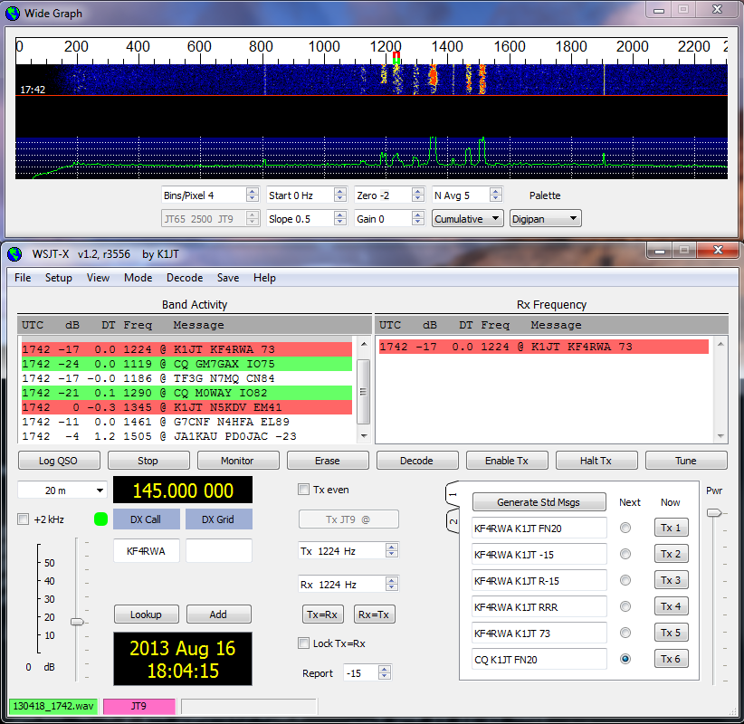

- Note that at least eight JT9 signals are present in the example file; all but one of them are decodable. When this file was recorded KF4RWA was finishing a QSO with K1JT. Since the green marker was placed at his audio frequency, 1224 Hz, his message “K1JT KF4RWA 73” appears in both decoded text windows. The “Band Activity” window shows this message as well as all the other decodes at nearby frequencies. The CQ lines are highlighted in green, and lines containing “My Call”, in this case K1JT, are highlighted in red. (For this step and the next one, you may want to pretend you are K1JT by entering that call temporarily as “My Call” on the Configuration screen. Your results should then be identical to those shown here.)
- To gain some feeling for the controls you will use when making QSOs, try clicking with the mouse on the decoded text lines and on the waterfall spectral display. You should be able to confirm the following behavior:
  - Double-click on either of the decoded lines highlighted in green. This action copies callsign and locator of a station calling CQ to the “DX Call” and “DX grid” entry fields. It also generates suitable messages for a minimal QSO and checks or clears the Tx even box so that you will transmit in the proper (odd or even) minutes. Rx and Tx frequency markers will be moved to the CQing station’s frequency, and the Gen Msg (“generated message”) radio button at bottom right of the main window will be selected. If you had checked “Double-click on call sets Tx Enable” on the Setup menu, Enable Tx would also be activated, and you would start to transmit automatically, at the appropriate time.
  - Double-click on the decoded line with the message “K1JT N5KDV EM41”, highlighted in red. Results will be similar to (a), except the Tx frequency (red marker) is not moved. Such messages are usually in response to your own CQ, or from a tail-ender, and you probably want your Tx frequency to stay where it was. By holding down the Ctrl key when double-clicking on the decoded line (or checking Lock Tx=Rx) you can cause both Tx and Rx frequencies to be moved.
  - Now double-click on the message from KF4RWA in either window. He is sending “73” to K1JT, signifying that the QSO is over. Most likely you want to send 73 to him, so the message “KF4RWA K1JT 73” is automatically generated and selected for your next transmission. (Alternatively, you might choose to send a free text message or to call CQ again.)
  - Clicking on the waterfall moves the Rx frequency (green marker) to the selected frequency. Ctrl-click on waterfall moves both Rx and Tx frequencies.
  - Double-click on the waterfall moves the Rx frequency and causes a narrow-band decode there at the new QSO frequency. Decoded text appears in the right window only. Ctrl-double-click moves both Rx and Tx frequencies and decodes at the new frequency.
  - Clicking Erase clears the right window. Double-click on Erase to clear both text windows.
- Now set Bins/Pixel = 7, Zero = -3, and Slope = 1.1. If necessary, adjust the width of the Wide Graph Window so that the upper frequency limit is 4000 Hz. Select JT9+JT65 on the Mode menu, toggle the Tx mode button to read Tx JT65, and set the Tx and Rx frequencies to 1718 Hz. Double-click on Erase to clear both text windows. Then open the sample file 130610_2343.wav. The waterfall and main window should look like the screen shot on the next page. This sample file contains 17 decodable signals — nine in JT65 mode (flagged with the character # in the decoded text windows), and eight in JT9 mode (flagged with @). Since the Tx mode was set to Tx JT65, signals in that mode were decoded first. If you had selected Tx JT9, JT9 signals would be decoded first.
- Notice the blue marker on the waterfall scale, by default set at 2500 Hz. Its position is set by the spinner control JT65 nnnn JT9, where nnnn is a frequency in Hz. In JT9+JT65 mode the program will decode JT65 signals below this frequency and JT9 signals above it.
- Confirm that mouse-click behavior is similar to that described in the single-mode instructions (item 4, above). The program automatically determines the mode of each JT9 or JT65 signal. For example, double-click on the waterfall near 815 Hz: a signal originating from W7VP will be decoded, and the line
2343 -7 0.3 815 # KK4DSD W7VP -16
should appear in the Rx Frequency text box. Double-click on the waterfall at 3196 Hz and the program will decode a JT9 message from IZ0MIT:
2343 -7 0.3 3196 @ WB8QPG IZ0MIT -11
Notice that when a signal is decoded in this way the Tx mode automatically switches to that of the decoded signal. The Rx and Tx frequency markers on the waterfall scale resize themselves accordingly.
- Scroll back in the Band Activity window (if necessary) and double-click on the message CQ DL7ACA JO40. The program will set Tx mode to JT65 and Tx and Rx frequencies to that of DL7ACA, 975 Hz. If you had checked Double-click on call sets Tx Enable on the Setup menu, the program would prepare itself to start a QSO with DL7ACA.
- Double-click on the decoded JT65 message CQ TA4A KM37. The program will set Tx mode to JT9 and both frequencies to 3567 Hz. You’re now configured properly for a JT9 QSO with TA4A.
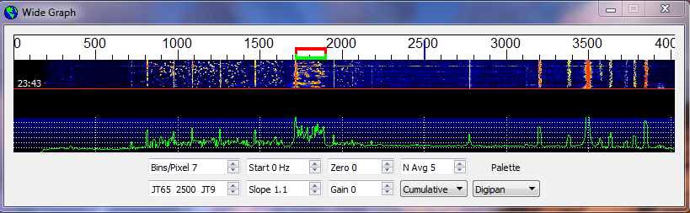
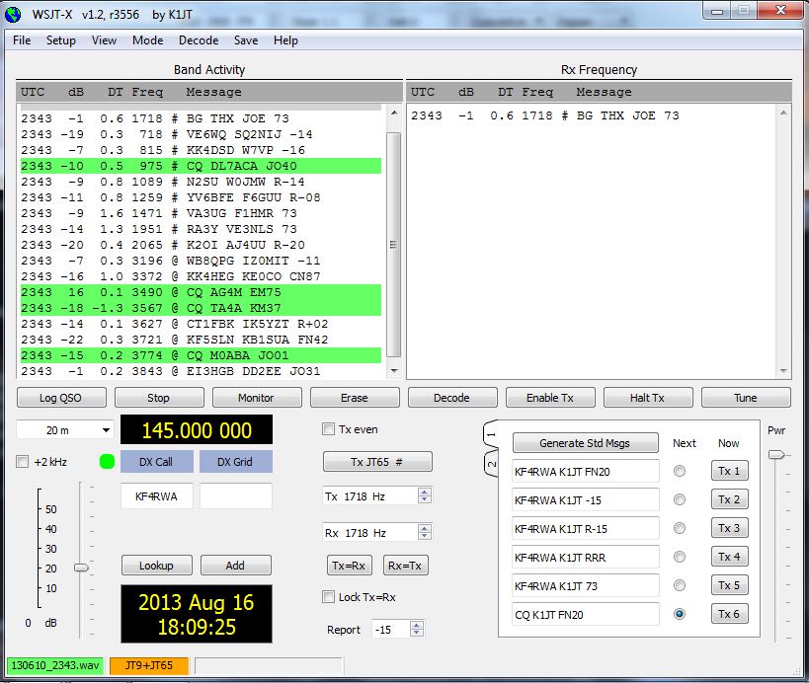

- Again open file 130418_1742.wav in the Samples directory. You can immediately see that this data was recorded with a much narrower Rx bandwidth, roughly 200 to 2600 Hz. If you have no Rx filter wider than about 2.7 kHz, you will necessarily use data similar to this sample. For best viewing of such data adjust Bins/Pixel and the width of the Wide Graph so that only the active part of the spectrum shows, say 0 to 2600 Hz. (Re-open the example file after any change of Bins/Pixel or Wide Graph width, to refresh the waterfall.) The signals in this file are all JT9 signals. To decode them in JT9+JT65 mode you’ll need to move the JT65 nnnn JT9 delimiter down to 1000 Hz or less.
- Now is a good time to experiment with the Start, Zero and Slope parameters. Start sets the starting frequency at the left side of the waterfall scale. Zero sets the baseline level for colors; its behavior is similar to that of the digital gain slider at lower left of the main window. Slope provides a way to correct for non-flat spectral response in your radio. For the receiver setup of this file a good value is around +0.6. If the Cumulative spectral baseline (green curve) slopes downward toward higher frequencies, increase the Slope setting. Re-open the wave file after each change, to see the new results. Here’s the resulting waterfall display with parameters set properly for my TS-2000 with 200-2600 Hz filter settings:
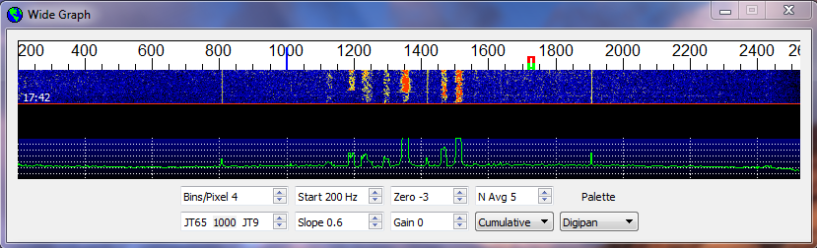
- Don’t forget to re-enter your own callsign as “My Call”. Click the Monitor button to return to normal receive operation, and be sure that your transceiver is set to USB (or USB Data) mode. Using the receiver gain control(s) and/or the Windows mixer controls, set the background noise level to around 30 dB or mid-scale (lower left of main window). If necessary you can also use the slider next to the scale — but note that the overall dynamic range will be best with this slider close to its mid-point.
- Frequency Setting: Taking full advantage of the wideband, dual-mode capability of WSJT-X v1.1 requires a receiver bandwidth of at least 4 kHz. For example, on a Kenwood TS-2000 I set Low Cut to 200 and High Cut to 5000 Hz. Note that most SSB transceivers have a fixed Tx filter that will not pass audio frequencies higher than about 2700 Hz. WSJT-X v1.1 takes care of this by using Split mode, receiving with VFO A and transmitting with VFO B. The Tx dial frequency (VFO B) is offset in 500 Hz steps, and the generated audio frequency is adjusted so that it always falls in the range 1500 – 2000 Hz. With CAT and Split Tx enabled on the configuration screen and your transceiver set to Split mode, frequency control will be handled automatically. (Note: operating in Split mode is not yet functional with CAT control through Ham Radio Deluxe.)
- If your transceiver has only a standard SSB filter you won’t be able to use more than about 2.7 kHz bandwidth. You can still have all of the JT9 sub-band and part of the JT65 sub-band available, however. On 20m, say, set dial frequency (VFO A) to 14.0774 and the JT9 nnnn JT65 dividing line at 1600 Hz. JT9 signals in their conventional sub-band will then appear at 1600 – 2600 Hz, while JT65 signals will be below 1000 Hz. Of course, you might prefer to concentrate on one mode at a time, setting your dial frequency to (say) 14.076 for JT65 and 14.078 for JT9. Present conventions have the nominal JT9 dial frequency 2 kHz higher than the JT65 dial frequency, and the checkbox labeled +2 kHz, just below the band selector, makes the appropriate settings easy.
- You should now be ready to make QSOs using either JT9 or JT65.

Making QSOs
By longstanding tradition, a minimal valid QSO requires the exchange of callsigns, a signal report or some other information, and acknowledgments. WSJT-X is designed to facilitate making such minimal QSOs using short, formatted messages. The process works best if you use these formats and follow standard operating practices. The recommended basic QSO goes something like this:
1. CQ K1ABC FN42
2. K1ABC G0XYZ IO91
3. G0XYZ K1ABC –19
4. K1ABC G0XYZ R–22
5. G0XYZ K1ABC RRR
6. K1ABC G0XYZ 73
These standard messages consist of two callsigns (or CQ, QRZ, or DE and one callsign) followed by the transmitting station’s grid locator, a signal report, or the acknowledgement “RRR” or “73”. These messages are compressed and encoded in a highly efficient and reliable way. Signal reports are given as signal-to-noise ratio in dB, using the standard reference noise bandwidth 2500 Hz. For JT65 they must lie in the range –30 to –1 dB; JT9 supports the extended range –50 to +49 dB.
In example message #3 K1ABC is telling G0XYZ that his signal is 19 dB below the noise power in bandwidth 2500 Hz. In message #4 G0XYZ acknowledges receipt of that report and responds with a –22 dB signal report. For operators with good hearing, signals start to become audible around –15 dB on this scale. Signals are visible on the waterfall down to about –26 dB. In ideal circumstances the JT65 decoder begins to fail at around –24 dB, JT9 around –26 dB.
Free-format messages such as “TNX JOE 73 GL” or “5W VERT 73 GL” can be sent, up to a maximum of 13 characters. Users often add some friendly chit-chat as a final transmission, in place of the formatted “73” message. It should be obvious, however, that JT9 and JT65 are not suitable for extensive conversations or rag-chewing.
Compound callsigns such as PJ4/K1ABC or G0XYZ/P are handled in a slightly different way. The following formats are all valid:
CQ pfx/callsign grid
QRZ pfx/callsign grid
DE pfx/callsign grid
CQ callsign/sfx grid
QRZ callsign/sfx grid
DE callsign/sfx grid
where “pfx” is a 1-4 character prefix, “callsign” is a standard callsign, “sfx” is a 1-3 character suffix, and “grid” is a 4-character Maidenhead locator, a signal report of the form “±nn” or “R±nn”, or the acknowledgment or signoff messages “RRR” or “73”. WSJT-X generates messages in these forms automatically, as required. A QSO between two stations using compound callsigns might look like this:
1. CQ KP4/K1ABC FK68
2. DE G0XYZ/P IO91
3. G0XYZ K1ABC –19
4. K1ABC G0XYZ R–22
5. G0XYZ K1ABC RRR
6. DE G0XYZ/P 73
Before attempting your first QSO with JT9 or JT65, be sure to go through the tutorial on pages 6 – 12 as well as the following checklist:
- Your callsign and grid locator set to correct values
- PTT and CAT control (if used) properly configured and tested
- Computer clock properly synchronized with UTC to within ±1 s.
- Radio set to USB (upper sideband) mode
- Remember that JT9 and JT65 generally do not require high power. Under most propagation conditions, QRP is the rule!

On-Screen Controls
The following controls appear at the bottom of the Wide Graph window:
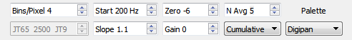
FFT Bins/Pixel controls the displayed frequency resolution. Set to 1 for the highest possible resolution, or to higher values to compress the spectral display. Normal operation with a convenient window size works well at 2 to 8 bins per pixel.
N Avg is the number of successive FFTs to be averaged before updating the spectral display. Values around 5 are suitable for normal JT9 and JT65 operation.
Gain and Zero control the scaling and reference level for waterfall colors. Values around 0 for both parameters are usually about right, depending on the input signal level and your own preferences.
Slope lets you make first-order corrections for a receiver spectral response that is not flat.
JT65 nnnn JT9 sets the dividing point for wideband decoding of JT65 and JT9 signals in JT9+JT65 mode. The decoder looks for JT65 signals below nnnn Hz and JT9 signals above that frequency.
Current / Cumulative / JT9 Sync controls the graphical display in the bottom one-third of the Wide Graph window. Current is the average spectrum over the most recent N Avg FFT calculations. Cumulative is the average spectrum since the start of the current Rx sequence.
With the exception of JT65 nnnn JT9, controls on the Wide Graph window affect only the graphical displays — they have no effect on the decoding process.
The following buttons appear just under the decoded text windows on the main screen:
Log QSO pops up a confirmation screen pre-filled with known information about a QSO you have nearly completed. You can edit or add to this information before clicking OK to log the QSO. If you select “Prompt me to log QSO” on the Setup menu, the program will pop up the confirmation screen automatically when you send a “73” or free-text message.
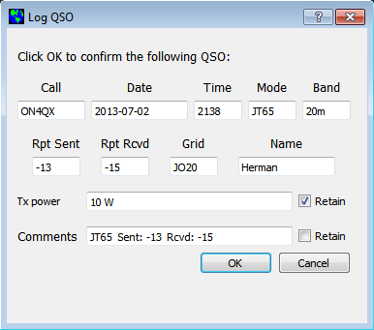
Stop will stop normal data acquisition in case you want to open and explore previously recorded audio files.
Monitor restarts normal receive operation. This button is highlighted in green when the program is receiving.
Decode tells the program to repeat the decoding procedure at the Rx frequency (green marker on waterfall), using the most recently completed sequence of Rx data.
Erase clears the right (Rx frequency) window. Double-clicking Erase clears both text windows.
Tune may be used to switch into Tx mode and generate an unmodulated carrier at the specified Tx frequency (red marker on waterfall). This process may be useful for adjusting an antenna tuner, for example. Toggle the button a second time to terminate the Tune process.
Enable Tx puts the program into automatic Rx/Tx sequencing mode and highlights the button in red. A transmission will start at the beginning of the selected (odd or even) sequence, or immediately if appropriate.
Halt Tx terminates a transmission in progress and disables automatic Rx/Tx sequencing.
Controls and displays related to date and time, frequency, Rx audio level, and the station being worked are found at lower left of the main window:
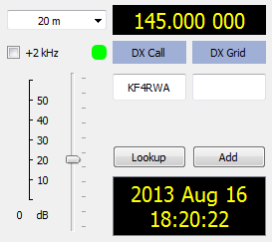
The drop-down Band selector at upper left lets you select the operating band and sets dial frequency to a default value taken from the Default Frequencies tab on the Setup | Configuration screen. If you are using CAT control, a small colored square appears in green if the CAT control is two-way between WSJT-X and your radio, or orange if the control is only from program to radio. (You can request a one-time interrogation of the radio’s dial frequency by clicking on the orange square.) The square becomes red if you have requested CAT control but communication with the radio has been lost.
If the Dx Grid is known, the great-circle azimuth and distance are given. The program can keep a database of callsigns and locators for future reference. Click Add to insert the present call and locator in the database; click Lookup to retrieve the locator for a previously stored callsign.
At center and right of the main window are a number of controls you will use when making QSOs. The following are near screen center:
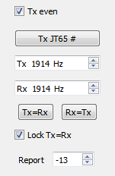
Select Tx even to transmit in even-numbered UTC minutes. Uncheck this box to transmit in the odd intervals. This selection is made automatically when you double-click on a decoded text line as described in the Basic Operating Tutorial, pages 6 – 12 of this Guide. Your audio Tx and Rx frequencies are displayed and can be adjusted with spinner controls. These settings are normally handled automatically by the double-click procedure. The on-the-air frequency of your lowest JT9 or JT65 tone is the sum of dial and audio frequencies. You can force Tx frequency to the current Rx frequency by clicking the Tx=Rx button, and vice-versa for Rx=Tx; check the box Lock Tx=Rx to make the frequencies always track one another. The Report control lets you change a signal report inserted automatically. Most reports will fall in the range –26 to +10 dB. When signals are close to or above 0 dB, you and your QSO partner should probably reduce power. JT65 and JT9 are supposed to be weak signal modes!
Two configurations of controls are provided for generating and selecting Tx messages:
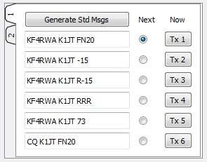
Traditional controls (carried over from program WSJT) provide six fields for message entry. Pre-formatted messages for the standard minimal QSO (see page 13) are generated when you click Generate Std Msgs, or when you double-click on an appropriate line of decoded text. Select the next message to be transmitted (at the start of your next Tx sequence) by clicking on the circle under Next. To change to a specified Tx message immediately, perhaps after a transmission has already started, click on a rectangular button (e.g., Tx 3) under the Now label. Changing Tx messages after a transmission has started reduces the probability of a correct decode by your QSO partner, but if you do it in the first 10 s of a Tx period it will most likely succeed.
Right-clicking on the entry field for message #5 pops up a list of free text messages entered on the Setup | Configuration | Tx Macros dialog window, for example
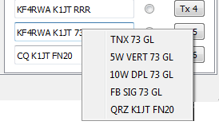
You can select any of these pre-stored messages with the left mouse button.

The second configuration of message-selecting controls looks like this:
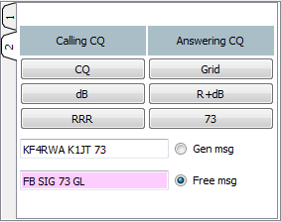
With this setup you will normally follow a top-to-bottom sequence of transmissions from the left column (if you are calling CQ) or the right column (if you are answering a CQ). Clicking a button puts the appropriate message in the Gen Msg box. If you are already transmitting, it changes the Tx message immediately. The actual message being transmitted always appears highlighted in yellow in the first box on the status bar, at the bottom left of the main screen. You can enter anything (up to 13 characters) in the Free Msg box. Right-clicking on this entry field pops up your previously defined list of Tx Macros.

Status Bar
A Status Bar at the bottom edge of the main window provides information about operating conditions.
Reading from left to right, these labels provide information about the current operating state (Receiving, Transmitting, Tune, or an opened file name), received noise level in dB, operating mode, and content of the most recent transmitted message.

Menus
Program menus offer many options for configuration and operation. You should explore them and test the resulting program actions.
File menu
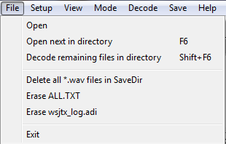

Setup menu
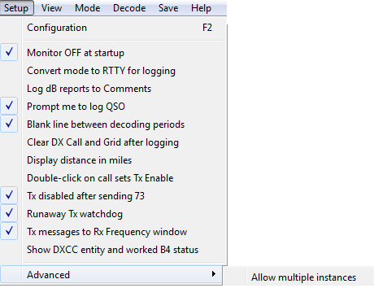
View menu
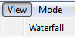
Mode menu
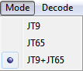
Decode menu
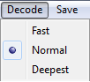

Save menu
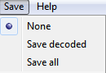
Help menu
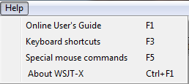

Keyboard Shortcuts
F1 Display online User's Guide in browser
Ctrl+F1 About WSJT-X
F2 Open the Setup | Configuration window
F3 Display keyboard shortcuts
F4 Clear Dx Call and Dx Grid entries
Alt+F4 Exit program
F5 Display special mouse commands
F6 Open next file in directory
Shift+F6 Decode all remaining files in directory
F11 Move Rx frequency down 1 Hz
Ctrl+F11 Move Rx and Tx frequencies down 1 Hz
F12 Move Rx frequency up 1 Hz
Ctrl+F12 Move Rx and Tx frequencies up 1 Hz
Alt+1-6 Set next transmission to this number on Tab 1
Alt+D Decode again at Rx frequency
Shift+D Full decode (both windows)
Alt+E Erase
Ctrl+F Edit the free text message box
Alt+G Generate standard messages
Alt+H Halt Tx
Ctrl+L Lookup callsign in database, generate standard messages
Alt M Monitor
Alt+N Enable Tx
Alt+Q Log QSO
Alt+S Stop monitoring
Alt+T Tune
Alt+V Save the most recently completed *.wav file

Special Mouse Commands
Mouse-click on | Action
Waterfall | Set Rx frequency  Double-click to set Rx frequency and decode there  Ctrl-click to set Rx and Tx frequencies  Ctrl-double-click to set Rx and Tx frequencies and decode there
Decoded text | Double-click to copy second callsign to Dx Call and locator to Dx Grid; change Rx and Tx frequencies to decoded signal's frequency; generate standard messages. If first callsign is your own, Tx frequency is changed only if Ctrl is held down when double-clicking.
Erase button | Click to erase QSO window  Double-click to erase QSO and Band Activity windows
Tx5 Entry | Right-click to select a macro message

Font Sizes
User control of font sizes can be effected by using Windows Notepad or a similar text editor to create a one-line file named fonts.txt in the wsjtx directory. The single line of text should contain four numbers separated by spaces. The first two control the font size (in points) and weight (on a 0 – 100 scale) of most GUI labels. The last two control size and weight of text in the Band Activity and Rx Frequency windows. The default is “8 50 10 50”. If you need larger fonts and bold text in the decode windows, try “10 50 12 100” (without the quotes).

Differences Between JT65 and JT9
JT65 is a mature mode described in the literature some years ago. Details of the JT9 protocol are presented in Appendix A of this Guide. To users already familiar with JT65, the most striking difference between the two modes is the much smaller occupied bandwidth of JT(: 15.6 Hz, compared with 177.6 Hz for JT65A. Transmissions in the two modes are essentially the same length, and both modes use exactly 72 bits to carry message information. At the user level the two modes support the same message structures.
JT65 signal reports are constrained to the range –1 to –30 dB — more than adequate for EME purposes, but not enough dynamic range for ideal use at HF and below. S/N values displayed by the JT65 decoder are clamped at –1 dB, because that’s all the original protocol can handle; the S/N scale in present JT65 decoders becomes increasingly nonlinear above –10 dB. By comparison, JT9 allows for signal reports in the range –50 to +49 dB. It manages this by co-opting a small amount of message space otherwise used for grid locators within 1 degree of the south pole. The S/N scale of the present JT9 decoder is reasonably linear, although it’s not intended as a precision measurement tool. With clean signals in a clean nose background, JT65 achieves nearly 100% probability of correct decoding down to S/N = –22 dB and 50% at –24 dB. JT9 is about 2 dB better, achieving 50% decoding at about –26 dB. Both modes produce extremely low false-decode rates.
Early experience suggests that under most HF propagation conditions the two modes have comparable reliability, with perhaps a slight edge to JT9. The tone spacing of JT9 is about two-thirds that of JT65, so in some disturbed ionospheric conditions in the higher portion of the HF spectrum, JT65 may do better. JT9 is an order of magnitude better in spectral efficiency. On a busy HF band, we often find the 2-kHz-wide JT65 sub-band filled wall-to-wall with signals. Ten times as many JT9 signals could fit into the same space, without overlap.

Appendix A: The JT9 Protocol and its Implementation
JT9 is a mode designed for making QSOs at HF, MF, and LF. The mode uses essentially the same 72-bit structured messages as JT65. Error control coding (ECC) uses a strong convolutional code with constraint length K=32, rate r=1/2, and a zero tail, leading to an encoded message length of (72+31) × 2 = 206 information-carrying bits. Modulation is 9-FSK: 8 tones are used for data, one for synchronization. Sixteen symbol intervals — those numbered 1, 2, 5, 10, 16, 23, 33, 35, 51, 52, 55, 60, 66, 73, 83, and 85 in the sequence — are devoted to synchronization, so a transmission requires a total of 206 / 3 + 16 = 85 (rounded up) channel symbols. Symbol durations are approximately (TRperiod - 8) / 85, where TRperiod is the T/R sequence length in seconds. Exact symbol lengths are chosen so that nsps, the number of samples per symbol (at 12000 samples per second) is a number with no prime factor greater than 7. This choice makes for efficient FFTs. Tone spacing of the 9-FSK modulation is df = 1 / tsym = 12000 / nsps, equal to the keying rate. The total occupied bandwidth is 9 × df. The generated signal has continuous phase and constant amplitude, so there are no key clicks.
For experimental purposes, submodes of JT9 were defined with transmission lengths greater than one minute. Parameters of all submodes are summarized in the following table, along with approximate decoding thresholds measured by simulation on an additive white Gaussian noise (AWGN) channel. Numbers following “JT9-” in the submode names specify the T/R sequence length in minutes. When not otherwise specified in this Guide, JT9 implies submode JT9-1, the only submode implemented in current versions of WSJT-X.
Submode | nsps | Symbol Duration  (s) | Tone Spacing (Hz) | Signal Bandwidth (Hz) | S/N Threshold* (dB) | QSO Time (minutes)
JT9-1 | 6912 | 0.58 | 1.736 | 15.6 | -27 | 6
JT9-2 | 15360 | 1.28 | 0.781 | 7.0 | -30 | 12
JT9-5 | 40960 | 3.41 | 0.293 | 2.6 | -34 | 30
JT9-10 | 82944 | 6.91 | 0.145 | 1.3 | -37 | 60
JT9-30 | 252000 | 21.00 | 0.048 | 0.4 | -42 | 180

* Noise power measured in 2500 Hz bandwidth.
Transmitting: Immediately before the start of a transmission WSJT-X encodes a user’s message and computes the sequence of tones to be sent. The transmitted audio waveform is computed on-the-fly, with 16-bit integer samples at a 48000 Hz rate. The digital samples are converted to an analog waveform in the sound card or equivalent USB interface.
Receiving and Decoding: WSJT-X acquires 16-bit integer samples from the sound card at a 12000 Hz rate. Spectra from overlapping data segments are computed for the waterfall display and saved at intervals of half the JT9 symbol length. As shown in screen shots earlier in this Guide, a JT9 signal appears in the Cumulative spectrum as a nearly rectangular shape about 16 Hz wide. Although there is no clearly visible “sync tone” like the one in JT65, by convention the nominal frequency of a JT9 signal is nevertheless taken to be that of the lowest tone at the left edge of the spectrum.
At the end of a reception sequence, about 50 seconds into the UTC minute, received data samples are forwarded to the decoder. For operator convenience the decoder goes through its full procedure twice: first over a narrow range around the selected Rx frequency, and then in the full displayed frequency range (or in JT9+JT65 mode, the displayed range above the blue JT65 nnnn JT9 marker). Decoding of clean JT9 signals in a white-noise background starts to fail around signal-to-noise ratio –25 dB and reached the 50% level at -26 dB
Each decoding pass can be described as a sequence of discrete blocks. For those wishing to study the program’s algorithms and source code, perhaps with an eye toward future improvements, the blocks are labeled here with the names of functional procedures in the code.
sync9: Use sync symbols to find candidate JT9 signals
in the specified frequency range

Then, at the frequency of each plausible candidate:
downsam9: Mix, filter and downsample to 16 complex samples/symbol

peakdt9: Using sync symbols, time-align to start of JT9 symbol
sequence

afc9: Measure frequency offset and any possible drift

twkfreq: Remove frequency offset and drift

symspec2: Compute 8-bin spectra for 69 information-carrying
symbols, using the time- and frequency-aligned data;
transform to yield 206 single-bit soft symbols

interleave9: Remove single-bit symbol interleaving imposed at the
transmitter

decode9: Retrieve a 72-bit user message using the sequential
"Fano" algorithm for convolutional codes

unpackmsg: Unpack a human-readable message from the 72-bit
compressed format

With marginal or unrecognizable signals the sequential Fano algorithm can take exponentially long times to completion. If the first step in the above sequence finds many seemingly worthy candidate signals, and if many of them turn out to be undecodable, the decoding loop could take a very long time. For this reason the decode9 step is programmed to “time out” and report failure if it takes too long. The choice Fast | Normal | Deepest on the Decode menu provides a three-step control of this timeout limit.

Appendix B: Installed and Generated Files
After installing WSJT-X as described in steps 1 and 2 on page 4, the following files will be present in the installation directory:
CALL3.TXT Callsign database
hamlib-alinco.dll Hamlib libraries
hamlib-amsat.dll ...
kamlib-dummy.dll
hamlib-flexradio.dll
hamlib-icom.dll
hamlib-jrc.dll
hamlib-kachina.dll
hamlib-kenwood.dll
hamlib-kit.dll
hamlib-tapr.dll
hamlib-tentec.dll
hamlib-winradio.dll
hamlib-yaesu.dll
HRDInterface001.dll Ham Radio Deluxe interface library
icudt51.dll
icuin51.dll
icuuc51.dll
jt9.exe Executable for JT9 decoder
jt9code.exe Test program to illustrate JT9 encoding
kvasd.dat Data for Koetter-Vardy decoder
kvasd.exe Executable Koetter-Vardy decoder
libgcc_s_dw2-1.dll gcc runtime
libhamlib-2.dll General hamlib library
libstdc++-6.dll Standard C function library
libwinpthread-1.dll Pthreads library
mouse_commands.txt Special mouse commands
Palettes Directory for waterfall palettes
palir-02.dll Linrad functions
platforms Directory for platform-specific library
qt.conf Empty Qt configuration file
Qt5Core.dll Qt libraries
Qt5Gui.dll ...
Qt5Multimedia.dll
Qt5Network.dll
Qt5Widgets.dll
save Directory for saved *.wav files
shortcuts.txt Keyboard shortcuts
unins000.dat Uninstall data
unins000.exe Executable for uninstalling WSJT-X
wsjt.ico WSJT icon
wsjtx.exe Executable for WSJT-X
WSJT-X_Users_Guide_v1.2.pdf WSJT-X User’s Guide
You might be curious about additional files that appear in the WSJT-X installation directory after using the program for a while. These include:
ALL.TXT Log of all received and transmitted messages
decoded.txt Decoded text from the most recent Rx interval
timer.out Diagnostic information for decoder optimization
wsjtx.ini Saved configuration parameters
wsjtx_log.adi ADIF log
wsjtx_status.txt Information sent to companion program JT-Alert

Appendix C: Linux, OS X, and Compiling from Source Code
Installation packages for Ubuntu 12.04, 12.10, 13.04, 13.10 are available at https://launchpad.net/~jnogatch/+archive/wsjtx
If you have not before obtained packages from the Personal Package Archive (PPA) at the above link, execute the following instruction at the command prompt:
$ sudo add-apt-repository ppa:jnogatch/wsjtx
To obtain the latest version from this PPA:
$ sudo apt-get update
$ sudo apt-get install wsjtx
You should also download kvasd and put it in the same directory as the executable binaries wsjtx and jt9. Normally (after you have run the script /usr/bin/wsjtx at least once) this directory will be $HOME/.wsjtx.
Installable binary packages for other Debian-based Linux systems and for OS X will be available soon.

Source Code
WSJT-X is an open-source program released under the GNU General Public License. Source code is available from the public repository at http://developer.berlios.de/projects/wsjt/. To compile the program you will need to install open source packages for Subversion, Qt 4.x or 5.x, g++, g95 or gfortran, portaudio, fftw3, and hamlib. For compiling in Windows I recommend installing the MinGW package.
The full source code for WSJT-X can be downloaded by using the command
svn co svn://svn.berlios.de/wsjt/branches/wsjtx

Acknowledgments
Many users of WSJT, too numerous to mention here individually, have contributed suggestions and advice that have greatly aided the development of WSJT-X and its sister programs. Since 2005 the overall project (including WSJT, MAP65, WSPR, WSJT-X, and WSPR-X) has been “open source”, all code being licensed under the GNU Public License (GPL). For WSJT-X in particular, I wish to acknowledge contributions from AC6SL, AE4JY, DJ0OT, G4KLA, G4WJS, K3WYC, KA6MAL, KA9Q, KK1D, PY2SDR, VK3ACF, VK4BDJ, and W4TV. Each has helped to bring the program’s design, code, and documentation to its present state.
Most of the color palettes for the WSJT-X waterfall were shamelessly copied from the excellent, well documented, open-source program fldigi, by W1HKJ and friends.

If you need an additional item in the list of devices for the CAT port, edit the configuration file wsjtx.ini and add your requirement as CATdriver=yourdriver (for example, CATdriver=/dev/tty.usbserial ) in the group of entries marked [Common].
Joe Taylor, K1JT: "The JT65 Communications Protocol" (QEX, September-October 2005).

